Project Report

1. **INTRODUCTION**

1.1 **overview**

Retail management is the process of running and managing retail outlets day to day activities surrounding the selling of goods and services to customers. Retail management helps in saving time and ensures that customers easily locate their desired merchandise and return home satisfied.

1.2 **purpose**

* Positioning of the retailer
* Immediate customer visibility
* Increasing the customer traffic
* Increasing sales
* Announcing special features
* New products

2 **problem Definition & Design Thinking**

2.1 Empathy Map

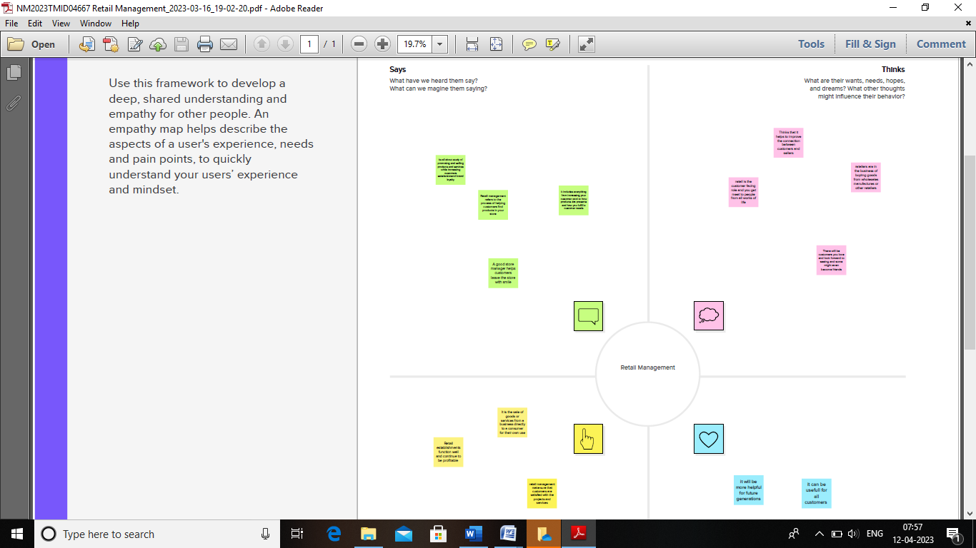

2.2 Ideation & Brainstorming Map

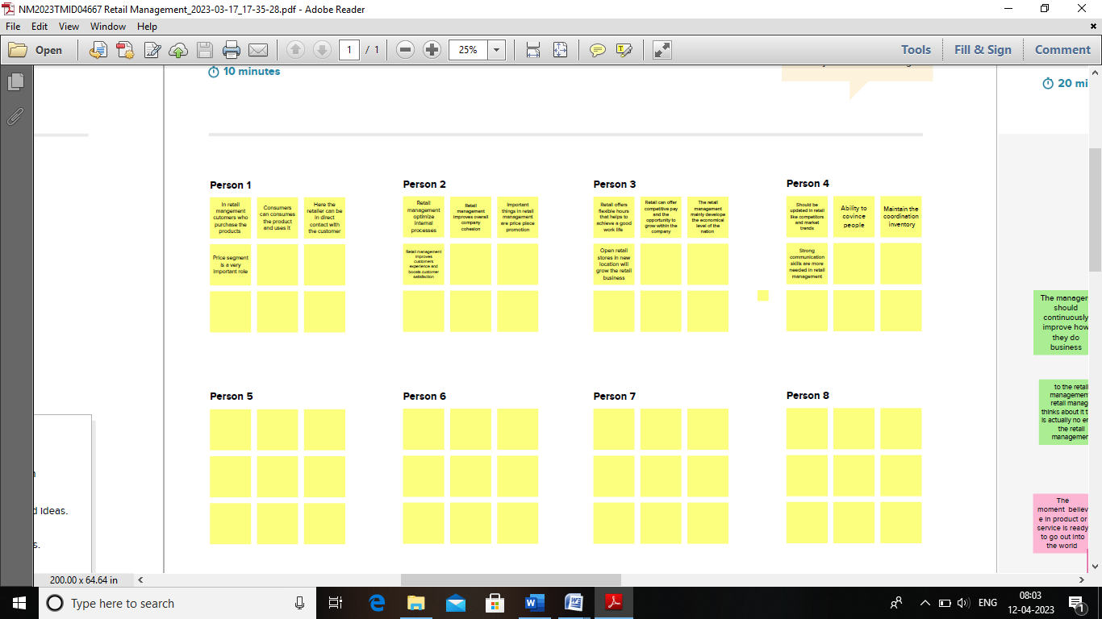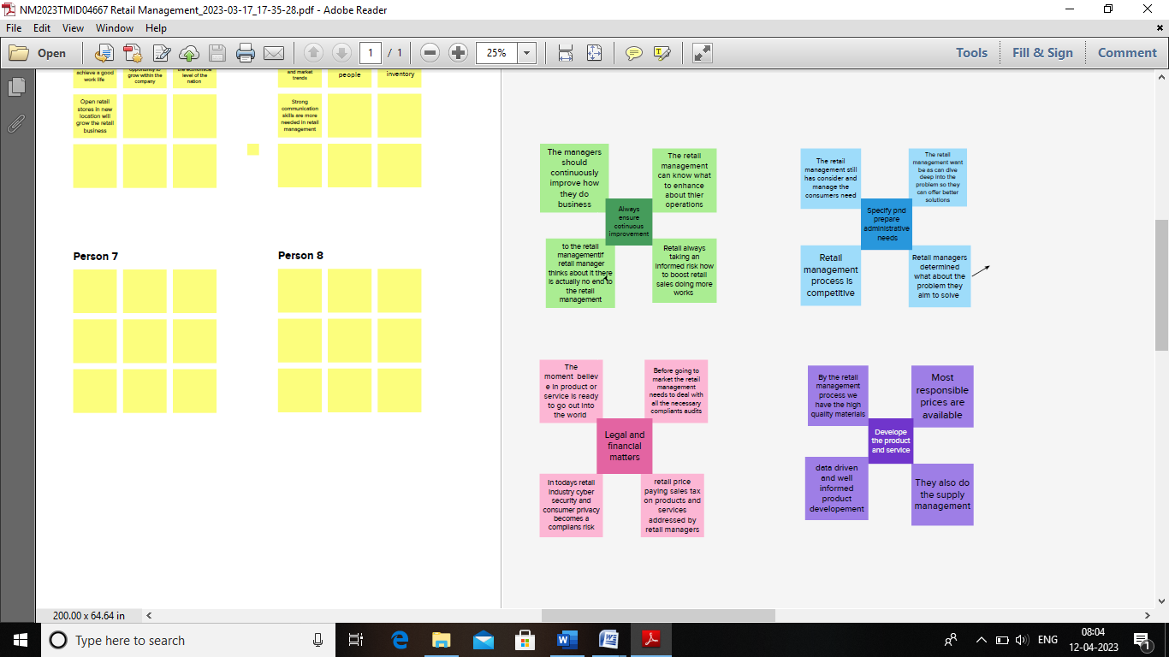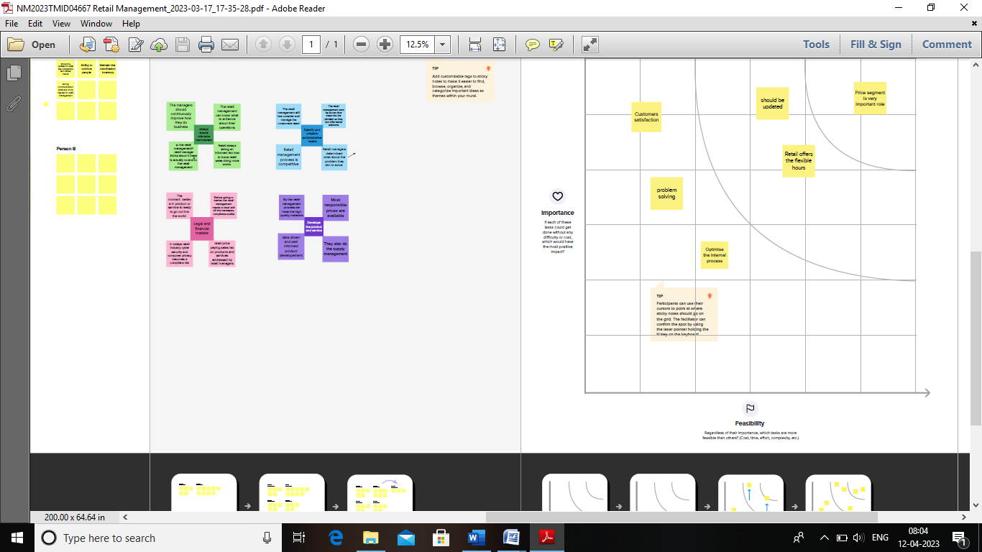

3 **Result**

**3.1 Data Model:**

|  |  |
| --- | --- |
| **Object Name** | **Fields in the Object** |
| **Dispatch/Tracking** | |  |  | | --- | --- | | **Field Label** | **Data Type** | | Dispatch/trackings | Text | | Dispatched | checkbox | | Dispatch/trackings | Master Detail relationship | |
| **Account** | |  |  | | --- | --- | | **Field Label** | **Data Type** | | phone | text | |
| **Contact** | |  |  | | --- | --- | | **Field Label** | **Data type** | | Account Website | formula | |

**3.2 Activity & Screenshot**

* First we need to login the salesforce through the new username and password
* Next in the Home page we can see the Object manager and create the new custom object

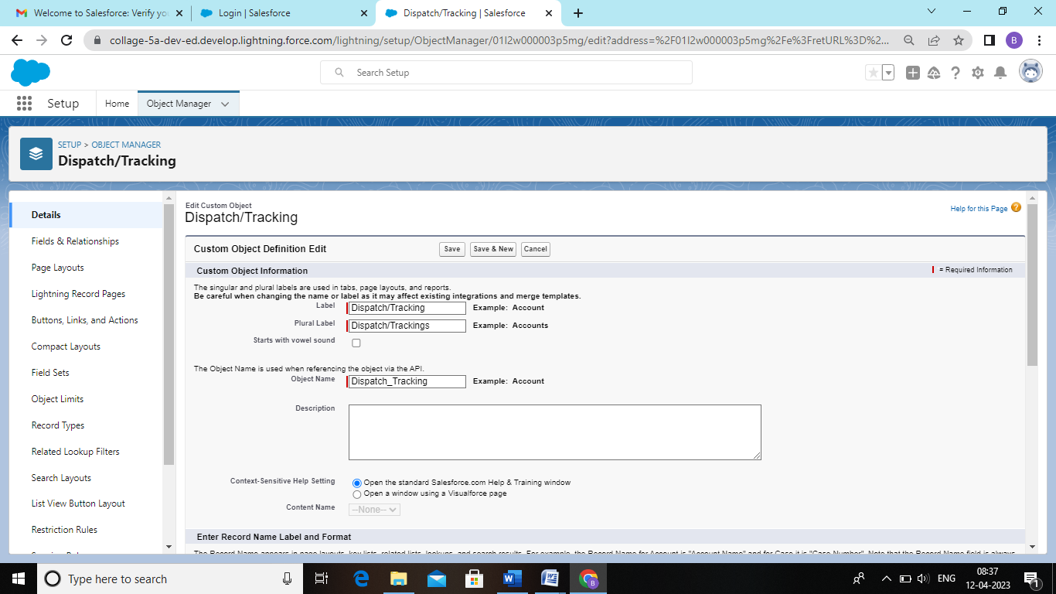

* In the next step go to the object manager and select the Dispatch/ Trackings and select the fields and relationships. Click new and select the data type has Checkbox

